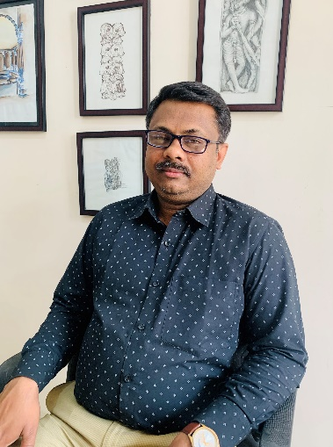
Professor B.Arch.
MSIA, Bijapur, Karnataka University

Empanelled Architect under GMDA and GMC, Assam

Registered Valuer of Nationalised Banks

Registered Architect under Council of Architecture (C.O.A.)

Academic Experience: 17 years
Industry Experience: 22 years
Research Interests: Building Materials, Vernacular Construction Techniques, Sustainable Building Methods

Email ID: siddhartha.deb@rgi.edu.in

